Faktlens Digital Services - Azure Migration Project
Final Technical Report
Daniel Igbu (GMNSE), Junior Cloud Engineer, student
What this report is
This is the final, complete write up of the Faktlens Digital Services Azure migration project. It brings together the architecture as it was planned in Session 1, the environment as it actually exists today, the full security review, and the troubleshooting log, into one document. The Security Review and the Troubleshooting Log are also kept as their own separate files with full detail, this report summarizes both and explains how they connect to the rest of the project.
The original client requirements
Faktlens Digital Services needed its website hosted on Azure, inside a properly structured environment, with a secured virtual machine running the site, a locked down way to administer it, private storage for documents and images, identity and access control matched to real business roles, monitoring and cost visibility, an awareness of backup and disaster recovery, and a documented comparison against alternative hosting approaches. Full documentation and a working, testable environment were expected throughout.
The environment as it actually exists
The image below is the Azure Resource Visualizer output for Faktlens-Cloud-RG, taken directly from the live environment. It shows every resource currently deployed and how they connect to each other.
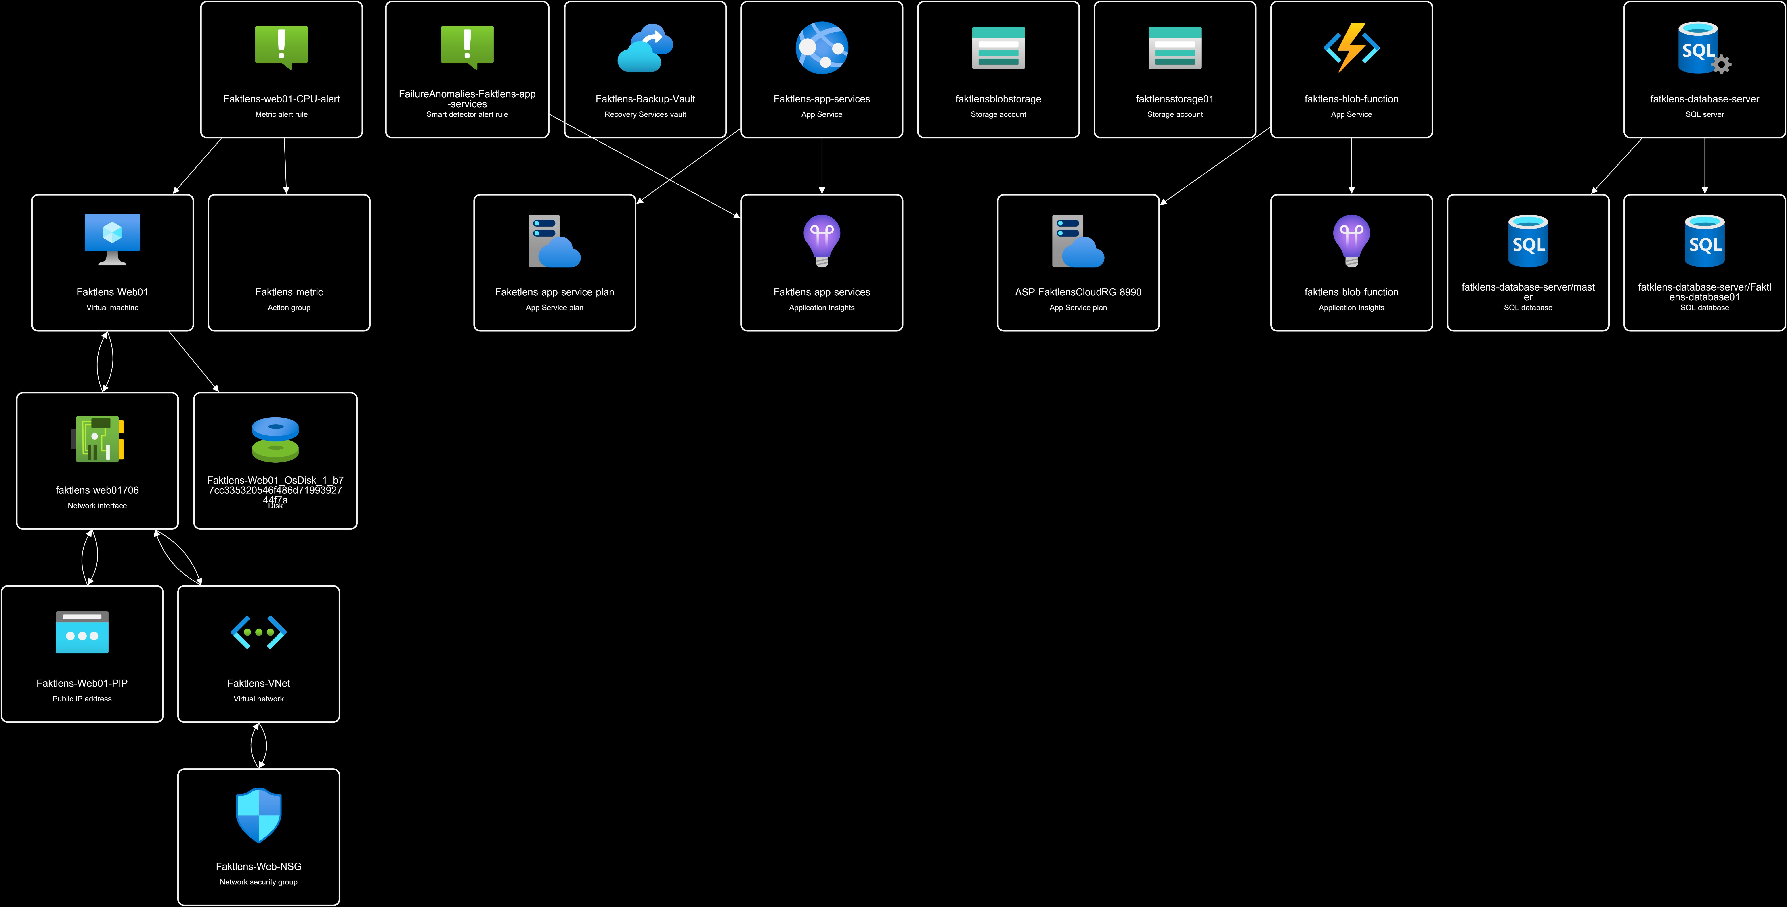
Figure 1: Resource Visualizer output for Faktlens-Cloud-RG

Resource inventory and naming
Resource Name | Type | Notes
Faktlens-Web01 | Virtual machine | Correctly named, matches convention
Faktlens-Web01-PIP | Public IP address | Correctly named
Faktlens-VNet | Virtual network | Correctly named
Faktlens-Web-NSG | Network security group | Actual name includes Web, my own notes had called it Faktlens-NSG, corrected here
faktlensstorage01 | Storage account | Correctly named, matches convention
Faktlens-Backup-Vault | Recovery Services vault | Correctly named
Faktlens-web01-CPU-alert | Metric alert rule | Correctly named
Faktlens-metric | Action group | Correctly named
faktlensblobstorage | Storage account | Not part of the naming convention, auto created for the Function App, flagged for deletion
Faktlens-app-services | App Service | Demonstration resource from Session 11, flagged for deletion
Faketlens-app-service-plan | App Service plan | Misspelled, and tied to a demonstration resource flagged for deletion
faktlens-blob-function | Function App | Demonstration resource from Session 12, flagged for deletion
fatklens-database-server | SQL server | Misspelled, and a demonstration resource from Session 9, flagged for deletion

Network and security summary
Faktlens-VNet holds two subnets, WebSubnet for the VM and ManagementSubnet reserved for a future admin path. Faktlens-Web-NSG allows ports 80 and 443 from anywhere, and port 3389 restricted to a single approved IP address. Storage containers are set to private access, and access across the environment is controlled through three Azure RBAC roles, Reader for the CEO, Contributor for the IT Administrator, and Cost Management Reader for the Finance Officer, each scoped to the Faktlens-Cloud-RG resource group only.
The full security review, including the findings confirmed through the resource visualizer and a prioritized list of what needs fixing, is kept in the separate Security Review document. The short version is that the network and access design itself is sound, but three demonstration resources and one auto created storage account were never cleaned up after the sessions that built them, and two resource names contain spelling mistakes. Both are addressed in that document with specific recommendations.
Hosting approach summary
The live website runs on Faktlens-Web01, a Windows Server VM with IIS installed, serving the site over both HTTP and HTTPS. Two alternative hosting approaches were also built and compared during the project, Azure App Service in Session 11 and Azure Functions in Session 12, along with Azure SQL Database in Session 9 as an alternative to running a database on a VM. All three comparisons concluded that the managed, platform based option would reduce day to day operational work for a business the size of Faktlens, though the VM remains the right choice where full control over the server is genuinely needed. None of these three demonstration resources are part of the live architecture, and all three are still physically present in the resource group, as detailed in the Security Review.
Storage summary
faktlensstorage01 holds three containers, documents, images, and backup, each set to private access with no public read permission. Blob soft delete is enabled with a short retention window, giving a simple recovery path for an accidentally deleted file without needing the full VM backup system.
Identity and access summary
Access to the environment is controlled through three RBAC roles matched to real business functions rather than left open on a single account. Microsoft Entra ID's Security Defaults setting is enabled on the tenant, providing baseline multi factor authentication for every user without needing a paid tier.
Monitoring and cost summary
A CPU based alert rule watches Faktlens-Web01 and notifies by email if usage stays unusually high. Application Insights and a smart detector alert rule also monitor the App Service resource. Cost Management was reviewed and a budget alert configured where the subscription allowed it, giving visibility into spend without needing to check manually on a schedule.
Backup and disaster recovery summary
Faktlens-Backup-Vault holds a daily backup policy for Faktlens-Web01, using the Enhanced policy type required for Trusted Launch VMs. Recovery point objective and recovery time objective targets were set for both the website and the documents in storage, and a written recovery procedure exists covering VM failure, accidental file deletion, and the honest limitation that a full regional outage is not currently covered by this setup.
Security review summary
The full Security Review document covers every finding in detail, ranked by priority. In short, the highest priority items are the three undeleted demonstration resources and the extra storage account tied to the Function App, all of which should be removed. Medium priority items include the two misspelled resource names and confirming network firewall settings have not been left wider than intended after earlier troubleshooting. The one low priority, accepted item is the VM's self signed certificate, which is expected and reasonable for a training environment.
Troubleshooting summary
The full Troubleshooting Log document lists ten real incidents encountered across the project, from a wrong VM image in Session 3 through to a typo blocking a Bicep deployment in Session 13. Each one is written up with what went wrong, what was checked, the actual root cause, the fix applied, and what would prevent it happening again. Taken together, they show a consistent pattern, almost every issue traced back to one specific, fixable detail once the actual error message or log was read carefully, rather than a sign of a fundamentally wrong approach.
Closing summary
The Faktlens environment meets the original requirements from Session 1, a working, secured website, private document storage, role based access control, monitoring, a documented backup plan, and documented alternatives for hosting, database, and event driven processing. The main outstanding action, identified through this final review, is deleting the three demonstration resources and the extra storage account that were never cleaned up, along with correcting two misspelled resource names. Both are captured with specific recommendations in the Security Review document, and once addressed, the environment matches the original target architecture with no unnecessary resources remaining.

